**VISVESVARAYA TECHNOLOGICAL UNIVERSITY**

**Jnana Sangama, Belagavi-590018**



Mini Project Report on

“TOURISM WEBSITE”

**Submitted in Partial fulfillment of the Requirements for the V Semester of the Degree of**

**Bachelor of Engineering in**

**Information Science & Engineering**

**By**

**KRUTIKA KAMALAKAR NAIK(1CR22IS406)**

**DIVYA SHREE V(1CR22IS402)**

**MAMATHA J R(1CR22IS407)**

**Under the Guidance of,**

**PARTHA CHATTOPADHYAY, Assistant Professor, Dept. of ISE**



**DEPARTMENT OF Information SCIENCE AND ENGINEERING**

**CMR INSTITUTE OF TECHNOLOGY**

Affiliated to VTU, Approved by AICTE, Accredited by NBA and NAAC with “A++” Grade

ITPL MAIN ROAD, BROOKFIELD, BENGALURU-560037, KARNATAKA, INDIA

**2023-24**

**CMR INSTITUTE OF TECHNOLOGY**

Affiliated to VTU, Approved by AICTE, Accredited by NBA and NAAC with “A++” Grade

ITPL MAIN ROAD, BROOKFIELD, BENGALURU-560037, KARNATAKA, INDIA

# DEPARTMENT OF INFORMATION SCIENCE AND ENGINEERING

**CERTIFICATE**

This is to certify that the Angular JS Mini Project work entitled **“Tourism Website”** has been carried out by **Krutika Kamalakar naik(1CR22IS406), Divya Shree V(1CR22IS402) and Mamatha JR(1CR22IS407)** bonafide students of CMR Institute of Technology, Bengaluru in partial fulfillment for the award of the Degree of **Bachelor of Engineering in Information Science and Engineering** of the Visvesvaraya Technological University, Belagavi during the year **2023-2024**. It is certified that all corrections/suggestions indicated for the Internal Assessment have been incorporated in the report deposited in the departmental library. This Angular JS Mini Project report has been approved as it satisfies the academic requirements in respect of project work prescribed for the said Degree.

|  |  |  |
| --- | --- | --- |
| **_____________________________**  **Signature of Guide**  **Partha Chattopadhyay**  **Assistant professor**  **Dept. of ISE, CMRIT** |  | **_____________________________**  **Signature of HOD**  **Dr. Jagadishwari V**  **Professor & HoD**  **Dept. of ISE, CMRIT** |

**DECLARATION**

We, the students of V semester from Department of Computer Science and Engineering, CMR Institute of Technology, Bangalore declare that the project work entitled “**Tourism Website**" has been successfully completed under the guidance of **Partha Chattopadhyay, Assistant Professor** Dept. of Information Science and Engineering, CMR Institute of technology, Bengaluru. This project work is submitted in partial fulfillment of the requirements for the award of the Degree of Bachelor of Engineering in Information Science and Engineering during the academic year 2023-2024. The matter embodied in the project report has not been submitted previously by anybody for the award of any degree or diploma to any university.

Place: Bangalore

Date:

**Team members:**

|  |  |
| --- | --- |
| **KRUTIKA KAMALAKAR NAIK**  **(1CR22IS406)** |  |
| **DIVYA SHREE V(1CR22IS402)** |  |
| **MAMTHA J R(1CR22IS407)** |  |

ABSTRACT

This project aims to develop a front-end tourism website using Angular, catering to users who seek information and inspiration for travel destinations. Unlike traditional tourism websites that focus on booking and trip planning, this website provides a user-friendly interface for browsing and exploring various destinations, attractions, and activities without the need for bookings or trip planning features.

The website will feature a responsive and visually appealing design. The website will utilize Angular's powerful framework to create dynamic and interactive user interfaces, enhancing the browsing experience for users. Features such as smooth transitions, lazy loading of content, and interactive elements will be implemented to engage users and encourage exploration.

**Acknowledgement**

I take this opportunity to express my sincere gratitude and respect to **CMR Institute of Technology, Bengaluru** for providing me a platform to pursue my studies and carry out the Angular JS Mini Project.

It gives me an immense pleasure to express my deep sense of gratitude to **Dr. Sanjay Jain,** Principal, CMRIT, Bengaluru, for his constant encouragement.

I would like to extend my sincere gratitude to **Dr. Jagadishwari V,** HOD, Department of Information Science and Engineering, CMRIT, Bengaluru, who has been a constant support and encouragement throughout the course of this project.

I would like to thank my guide **Partha Chattopadhyay, Assistant Professor** Department of Information Science and Engineering, for the valuable guidance throughout the tenure of the project work.

I would also like to thank all the faculty members of Department of Information Science and Engineering who directly or indirectly encouraged me.

Finally, I thank my parents and friends for all the moral support they have given me during the completion of this work.

**TABLE OF CONTENTS**

|  |  |
| --- | --- |
| **Contents** | **Page No.** |
| Certificate | ii |
| Declaration | iii |
| Abstract | iv |
| Acknowledgement | v |
| Table of contents | vi |
| List of Figures | vii |
| List of Tables | viii |
| 1. Introduction | 1 |
| 1. System Requirements    1. Hardware Requirements    2. Software Requirements | 2 |
| 1. Design    1. Schema Diagram    2. ER Diagram | 3-4 |
| 1. Implementation | 5-12 |
| 1. Interpretation of Result | 12-18 |
| 1. Conclusion and Future Scope | 19 |
| 1. References | 20 |

1

**CHAPTER-1**

**INTRODUCTION**

Tourism Website, a dynamic platform designed to showcase the beauty and diversity of travel destinations around the world. This project harnesses the power of Angular to create a seamless and immersive user experience, allowing visitors to explore various destinations, attractions, and activities from the comfort of their screen

The primary objective of this project is to provide users with a visually appealing and user-friendly interface that inspires them to discover new travel destinations and plan their future trips. By leveraging Angular's robust features and components, we aim to create an engaging platform that encourages exploration and fosters a sense of wanderlust

**FEATURES:**

**Interactive destination gallery**: Users can browse through a curated collection of stunning images and videos showcasing popular travel destinations.

**User feedback**: Visitors can share their travel experiences and insights through interactive feedback forms and ratings

audience includes travel enthusiasts, adventure seekers, families, and individuals looking for inspiration and information to plan their next vacation. By offering a visually appealing and informative platform, we aim to cater to the diverse interests and preferences of travelers in Karnataka

**objectives:**

**Information dissemination**: Provide comprehensive information about tourist destinations, attractions, activities

**User engagement:** Design an engaging user interface that encourages exploration and interaction, such as through beautiful imagery, and engaging content.

**Promotion of tourism:** Showcase the unique features and highlights of different tourist destinations to promote tourism and attract visitors

**Feedback mechanism:** Include a feedback mechanism or contact form to gather user feedback, suggestions, and inquiries, allowing for continuous improvement of the website.

**Scope of the project:**

This scope outlines the basic functionalities and features for a front-end tourism website using Angular. The absence of booking and trip planner functionalities simplifies the scope, focusing primarily on providing information and inspiration for travelers.

**SYSTEM REQUIREMENTS:**

To be used efficiently, all computer software needs certain hardware components or other software resources to be present on a computer. These prerequisites are known as system requirements and are often used as a guideline as opposed to an absolute rule.

**Hardware requirements:**

1. A personal computer/laptop
2. Processor: Intel core i3
3. Ram: Minimum 8gb
4. Operating system: Windows 10

**Software requirements**

* + 1. User-Interface: Angular, CSS, JavaScript

**Design:**

**Architecture:**

Angular Framework: Use Angular to build a single-page application (SPA) for the front end.

No Backend: Since there's no backend, the website will be static and data will be hardcoded or stored locally in the application.

**Front-End Components:**

Navigation Bar: Implement a navigation bar component for easy navigation between different sections of the website.

Homepage: Design a visually appealing homepage featuring popular destinations, special offers, or featured tours.

Destinations Page: Create a page displaying various destinations or tours. Each destination can be represented as a component.

Destination Details Page: Design individual pages for each destination with detailed information such as images, descriptions, activities, and map location.

About Page: Create a page with information about the website, company, or tourism organization.

Contact Page: Design a page with contact information and possibly a contact form for inquiries or feedback.

**IMPLEMENTATION:**

**Project code:**

**Index.html**

<!DOCTYPE html>

<html lang="en">

<head>

<meta charset="UTF-8">

<meta http-equiv="X-UA-Compatible" content="IE=edge">

<meta name="viewport" content="width=device-width, initial-scale=1.0">

<title>ADVENTURE</title>

<link rel="stylesheet" href="https://cdnjs.cloudflare.com/ajax/libs/font-awesome/4.7.0/css/font-awesome.min.css">

<link rel="stylesheet" href="css/style.css">

<link rel="stylesheet" href="css/responsive.css">

<link rel="apple-touch-icon" sizes="180x180" href="img/apple-touch-icon.png">

<link rel="icon" type="image/png" sizes="32x32" href="img/favicon-32x32.png">

<link rel="icon" type="image/png" sizes="16x16" href="img/favicon-16x16.png">

<link rel="manifest" href="/site.webmanifest">

</head>

<body ng-controller="MainController">

<nav class="navbar glass" style="height: 70px">

<span>

<a href="#home" style="display: flex; align-items: center">

<img class="img2" src="./img/mountain.png" width="40" style="margin: -25px -10px -25px -20px" />

<h1 class="logo">&nbsp;ADVENTURE</h1>

</a>

</span>

<ul class="nav-links">

<li><a href="#home" id="pri" class="active cir_border">Home</a></li>

<li><a href="#events" id="sec" class="cir_border">Events</a></li>

<li><a href="#explore" id="tri" class="cir_border">Explore</a></li>

<li><a href="#tours" id="quad" class="cir_border">Tours</a></li>

<li><a href="#about" id="quint" class="cir_border">About</a></li>

<li><a href="#contribution" id="hex" class="cir_border">Contributions</a></li>

<li><a href="#contact" id="hept" class="cir_border">Contact</a></li>

<li>

<div>

<input type="checkbox" class="checkbox dark" id="checkbox" />

<label for="checkbox" class="label">

<i class="fa fa-moon-o"></i>

<i class="fa fa-sun-o"></i>

<div class="ball"></div>

</label>

</div>

</li>

</ul>

<img src="./img/menu-btn.png" alt="" class="menu-btn" />

</nav>

<!-- Home Section -->

<header id="home">

<div class="header-content">

<h2 id="quote">Explore the Beauty of Karnataka</h2>

<div class="line"></div>

<h1>GOD'S WONDERFUL GIFT</h1>

<a href="#about" class="ctn" onclick='removeall(); $("#quad").css("border", "2px solid whitesmoke"); $("#quad").css("border-radius", "20px");'>Learn more</a>

</div>

</header>

<!-- Events Section -->

<section class="events" id="events">

<div class="container">

<div class="title">

<h1 class="dark">Upcoming Events</h1>

<div class="line"></div>

</div>

<div class="row">

<article class="card col">

<img class="card-img" src="./img/img1.jpg" />

<h4 class="dark">Chamundi temple visit</h4>

<p class="font-color">Chamundi temple visit is without a doubt, one of the most renowned travel destinations in Karnataka.</p>

<a href="#" class="ctn">All Details</a>

</article>

<article class="card col">

<img src="./img/img2.jpg" />

<h4 class="dark">Murudeshwara</h4>

<p class="font-color">Join small guided group temple and beaches, enjoy a challenging ocean, or a luxury private guided walk which can be made especially for you.</p>

<a href="#" class="ctn">All Details</a>

</article>

<article class="card col">

<img src="./img/im.jpg" />

<h4 class="dark">Malpe Beaches</h4>

<p class="font-color">Diving in Malpe Beaches is exceptional. The coastal belt surroundings are one of the richest beaches in India.</p>

<a href="#" class="ctn">All Details</a>

</article>

</div>

</div>

</section>

<!-- Explore Section -->

<section class="explore" id="explore">

<div class="explore-content">

<h1>EXPLORE KARNATAKA</h1>

<div class="line"></div>

<p>“Travel makes one modest. You see what a tiny place you occupy in the world.”– Gustav Flaubert <br />Exploring will make you want to pack your bag, book that ticket and jet away.</p>

<a href="#" class="ctn">Explore more</a>

</div>

</section>

<!-- Tours Section -->

<section class="tours" id="tours">

<div class="container row">

<div class="col content-col">

<h1 class="font-color">UPCOMING TOURS & DESTINATION</h1>

<div class="line"></div>

<p>Thursday 07 March 2024 : Mysuru Palace <br />Friday 08 March 2024 : Chamundi Betta.<br />Saturday 09 March 2024 : KRS Dam. <br />and many more ......</p>

<a href="#" class="ctn">Learn more</a>

</div>

<div class="image-col">

<div class="image-gallery">

<img src="./img/img3.png" alt="" />

<img src="./img/img4.png" alt="" />

<img src="./img/img5.png" alt="" />

<img src="./img/img6.png" alt="" />

</div>

</div>

</div>

</section>

<!-- About Section -->

<section id="about">

<div class="title">

<h1 class="font-color">About Us</h1>

<div class="line"></div>

</div>

<div id="about_us">

<div class="boxx">

<div class="containerx">

<input type="radio" name="slider" id="item-1" checked />

<input type="radio" name="slider" id="item-2" />

<input type="radio" name="slider" id="item-3" />

<div class="cards">

<label class="cardt" for="item-1" id="col-img-1">

<img src="./img/carousel-img4.jpg" />

</label>

<label class="cardt" for="item-2" id="col-img-2">

<img src="./img/carousel-img5.jpg" />

</label>

<label class="cardt" for="item-3" id="col-img-3">

<img src="./img/carousel-img6.jpg" />

</label>

</div>

</div>

<span id="about-quad">

<a href="#home">

<center>

<h1 style="font-family: var(--ff-montserrat); color: white;">Find that</h1>

<br />

<img class="img2" src="./img/mountain_dark.jpg" width="300" style="border-radius: 20%" />

<br />

<h1 class="logo" style="font-size: 50px">ADVENTURE</h1>

</center>

</a>

</span>

</div>

</div>

</section>

<!-- Contributors Section -->

<section class="contributors" id="contribution">

<div class="title">

<h1 class="font-color">Contributors</h1>

<div class="line"></div>

</div>

<div class="concard">

<div class="text">

<h1>Krutika Naik</h1>

<h1>Divya shree V</h1>

<h1>Mamatha JR</h1>

</div>

</div>

</section>

<!-- Contact Section -->

<section id="contact">

<div class="title">

<h1 class="font-color">Contact Us</h1>

<div class="line"></div>

</div>

<div class="contact_us">

<form class="cform" action="submit.html" method="get">

<div class="crow-message">

<h1 class="color">Send us a message</h1>

<div></div>

</div>

<div class="crow-in">

<input type="text" id="name" name="name" placeholder="Your name" />

<input type="text" id="email" name="email" placeholder="Your Email id" />

</div>

<div class="crow">

<div class="ccol-left">

<select name="country" id="country">

<option value="Mysuru">Mysuru</option>

<option value="Udupi">Udupi</option>

<option value="Murudeshwara">Murudeshwara</option>

<option value="Gokarna">Gokarna</option>

<option value="Mangalore">Mangalore</option>

<option value="Chikmagalur">Chikmagalur</option>

</select>

</div>

</div>

<div class="crow">

<div class="ccol-left">

<textarea type="text" id="remarks" name="remarks" placeholder="Your Remarks....." style="height: 150px"></textarea>

</div>

</div>

<input class="crow-s" type="submit" value="Submit" />

</form>

<div class="cbox">

<div>

<p class="cbox-message">Prefer some other way ?<br />Reach us by using the details given below</p>

<div class="cbox-line"></div>

</div>

<div class="c_boxx">

<a href="mailto:abc@gmail.com">

<i class="fa fa-envelope"></i>

Mail: uktourism@adventure.com

</a>

</div>

<div class="c_boxx">

<a href="tel:+91-97422-42290">

<i class="fa fa-phone"></i>

Phone: (+91) 7665678990

</a>

</div>

<div class="c_boxx">

<a href="#">

<i class="fa fa-map-marker"></i>

Location: Bengaluru, Karnataka, India

</a>

</div>

</div>

</div>

</section>

<i class="arrow" onclick="topFunction()" id="upbtn"></i>

<section class="footer">

<span>Created By Krutika Naik</span>

</section>

<script src="https://ajax.googleapis.com/ajax/libs/angularjs/1.8.2/angular.min.js"></script>

<script>

angular.module('adventureApp', [])

.controller('MainController', function($scope, $location, $anchorScroll) {

$scope.navigateToTours = function() {

$location.hash('tours');

$anchorScroll();

};

});

</script>

</body>

</html>

**Submit.html**

<!DOCTYPE html>

<html lang="en">

<head>

<meta charset="UTF-8">

<meta name="viewport" content="width=device-width, initial-scale=1.0">

<title>Submission Confirmation</title>

<style>

body {

margin: 0;

padding: 0;

background-image: url('bgimage.png');

background-size: cover;

background-position: center;

font-family: Arial, sans-serif;

color: #fff;

text-align: center;

display: flex;

justify-content: center;

align-items: center;

height: 100vh;

}

.message {

background-color: rgba(0, 139, 139, 0.7);

padding: 20px;

border-radius: 10px;

}

</style>

</head>

<body>

<div class="message">

<h1>Thanks for your valuable Feedback</h1>

<h1>Our Team will contact you soon.</h1>

</div>

</body>

</html>

**Style.css**

/* Google fonts */

@import url("https://fonts.googleapis.com/css2?family=Lora:wght@400;700&family=Montserrat:wght@400;800&family=Parisienne&family=Roboto&family=Teko:wght@300&display=swap");

@import url("https://fonts.googleapis.com/css2?family=Rubik+Dirt&display=swap");

/* Root element (aka html) */

:root {

box-sizing: border-box;

scroll-behavior: smooth;

/* CSS Variables */

/* Fonts */

--ff-parisienne: "Parisienne", cursive;

--ff-montserrat: "Montserrat", sans-serif;

--ff-lora: "Lora", serif;

--ff-roboto: "Roboto", sans-serif;

--ff-rubik-dirt: "Rubik Dirt", cursive;

--fs-paragraphs: calc(0.8rem + 0.35vw);

--fs-links-btns: calc(0.65rem + 0.5vw);

}

/* Global */

*,

*::before,

*::after {

margin: 0;

padding: 0;

box-sizing: inherit;

}

img {

max-width: 100%;

display: block;

}

a {

text-decoration: none;

}

ul {

list-style: none;

}

span {

color: #7c7c7c;

padding: 0px 40px;

}

/* .active {

color: #fc036b;

border-radius: 20px;

background: whitesmoke;

font-weight: bold;

} */

body,

html {

overflow-x: hidden;

box-sizing: border-box;

}

.container {

width: 98%;

max-width: 91rem;

margin: 0 auto;

}

/*scrollbar*/

::-webkit-scrollbar {

width: 10px;

}

::-webkit-scrollbar-thumb {

background: gray;

border-radius: 10px;

}

/*Navbar */

.navbar {

position: fixed;

top: 0;

left: 0;

background: rgba(0, 0, 0, 0.2);

backdrop-filter: saturate(180%) blur(10px);

display: flex;

width: 100%;

justify-content: space-between;

align-items: center;

padding: 12px 5px;

z-index: 10;

color: whitesmoke;

}

.logo {

font-family: var(--ff-rubik-dirt);

font-size: 1.5rem;

text-transform: uppercase;

letter-spacing: 0.4rem;

padding: 0 1.2rem;

font-weight: 300;

color: rgb(254, 252, 252);

}

.nav-links {

display: flex;

align-items: center;

}

.nav-links li {

font-family: var(--ff-montserrat);

margin: 0px 15px;

}

.nav-links li a {

color: white;

cursor: pointer;

}

.cir_border {

padding: 6px 20px;

font-weight: bold;

border: 2px hidden whitesmoke;

border-radius: 20px;

margin: 0px -10px;

}

header {

width: 100vw;

height: 100vh;

background-image: url("../img/bg.png");

background-position: bottom;

background-attachment: fixed;

background-size: cover;

display: flex;

align-items: end;

justify-content: center;

}

.header-content {

font-family: var(--ff-lora);

letter-spacing: 0.5rem;

color: whitesmoke;

text-align: center;

z-index: 1;

padding: 4rem;

margin-bottom: 150px;

}

.header-content a {

letter-spacing: 0.1rem;

}

.header-content h2 {

font-size: 4vmin;

}

.line {

width: 150px;

height: 4px;

background: #fc036b;

margin: 10px auto;

border-radius: 5px;

}

.header-content h1 {

font-size: 7vmin;

margin-top: 50px;

margin-bottom: 30px;

}

.ctn {

font-family: var(--ff-montserrat);

font-size: var(--fs-links-btns);

font-weight: 700;

padding: 13px 50px;

background: #fc036b;

border-radius: 30px;

color: whitesmoke;

}

.menu-btn {

position: absolute;

top: 30px;

right: 30px;

width: 40px;

cursor: pointer;

display: none;

}

/* Events */

section {

width: 80%;

margin: 80px auto;

}

.title {

text-align: center;

font-family: var(--ff-montserrat);

font-size: 4vmin;

}

.row {

display: flex;

width: 100%;

justify-content: space-between;

align-items: center;

}

.card {

cursor: pointer;

height :400px

}

.row .col {

display: flex;

flex-direction: column;

align-items: center;

margin: 10px;

height: 450px;

}

.row .col img {

width: 90%;

}

.events .row {

margin-top: 50px;

}

.col > h4 {

font-size: calc(1rem + 0.5vw);

margin: 20px auto;

font-family: var(--ff-lora);

}

.col p {

color: #7c7c7c;

padding: 0px 40px;

font-size: var(--fs-paragraphs);

font-family: var(--ff-roboto);

}

.col > p {

color: #7c7c7c;

padding: 0;

line-height: 1.5;

text-align: center;

max-width: 35ch;

}

.events .ctn {

margin-top: 30px;

}

/* explore */

.explore {

width: 100%;

height: 100vh;

background-image: url(../img/bg2.png);

background-attachment: fixed;

background-position: center;

background-size: cover;

background-repeat: no-repeat;

display: flex;

align-items: center;

}

.explore-content {

font-family: var(--ff-lora);

color: whitesmoke;

display: flex;

align-items: center;

flex-direction: column;

margin-left: 8rem;

position: relative;

z-index: 1;

padding: 2rem 17px;

margin: auto;

}

.explore-content::after {

content: "";

position: absolute;

inset: 0;

z-index: -1;

display: block;

background: rgba(0, 0, 0, 0.2);

backdrop-filter: blur(2.5px);

border-radius: 0.5rem;

}

.explore-content h1 {

/* width: 100%; */

font-size: calc(2.2rem + 1vw);

letter-spacing: 0.3rem;

margin: auto;

}

.explore-content .line {

margin-bottom: 50px;

}

.explore-content p {

color: rgb(221, 221, 221);

max-width: 65ch;

line-height: 1.5;

text-align: left;

padding: 0px 35px;

}

.explore-content .ctn {

margin: 17px auto;

padding: 12px 27px;

}

/* tours */

.image-gallery {

display: grid;

gap: 1.8rem 1rem;

grid-template-columns: repeat(2, 1fr);

justify-content: center;

padding: 1rem;

}

.tours .row {

gap: 4rem;

}

.content-col {

position: relative;

}

.content-col h1 {

font-size: calc(2.2rem + 1vw);

font-family: var(--ff-lora);

max-width: 15.5ch;

}

.content-col .line {

margin-left: 0;

}

.content-col p {

padding: 0;

margin: 30px 0;

width: 100%;

text-align: left;

max-width: 40ch;

}

.content-col .ctn {

position: absolute;

left: 0;

bottom: -14%;

}

/* about */

#about {

width: 100%;

}

#about_us {

background: url("https://awe365.com/wp-content/uploads/2013/07/adventure-sports-hang-gliding-flickrcc-image-by-Steve-Slater.jpg");

width: 100%;

height: 630px;

background-repeat: no-repeat;

background-size: cover;

background-attachment: fixed;

margin: 30px 0px 0px 0px;

}

#about_us div {

padding: 10px;

display: grid;

align-items: center;

grid-template-columns: 2fr 1fr 1fr;

column-gap: 5px;

position: relative;

}

#about_us div span {

margin: 0;

position: absolute;

top: 60%;

opacity: 0;

left: 80%;

-ms-transform: translate(-50%, -50%);

transform: translate(-50%, -50%);

transition: 1s;

}

#about_us p {

width: 43em;

color: white;

text-align: justify;

padding-top: 14em;

font-family: "Work Sans", sans-serif;

margin-left: 6em;

}

#about_us p::first-letter {

padding-left: 47px;

font-size: 55px;

color: #fc036b;

}

/* Contributors */

.contributors {

display: flex;

align-items: center;

justify-content: space-evenly;

margin-top: 0em;

padding: 5em 2em;

flex-wrap: wrap;

width: 100%;

min-height: 100vh;

background-color: #000;

font-family: "Montserrat", sans-serif;

}

.concard {

background-color: #ffff;

padding: 0.2em 0.5em;

color: #222;

height: 12em;

width: 10em;

border-radius: 5px;

margin: 1.5em 0.5em;

display: flex;

flex-direction: column;

align-items: center;

justify-content: center;

}

.concard:hover {

background-color: #fb036b;

border-bottom: 5px solid #fff;

color: #fff;

transform: translateY(-7.5px);

transition: background-color 0.5s ease, transform 1s ease,

border-bottom 0.5s ease 0.2s;

}

.concard .pfp {

width: 50%;

border-radius: 100%;

}

.text {

margin: 1em 0em 0em 0em;

text-align: center;

font-size: 0.9em;

}

.text h1 {

font-weight: 600;

font-size: 20px;

font-family: "Teko", sans-serif;

}

.logolink {

margin: 0.6em 0em 0em 0em;

width: 25%;

}

.logolink img {

border-radius: 100%;

background-color: #ffff;

}

.logolink .github-logo {

width: 100%;

}

/* contact */

#contact {

width: 90%;

}

.contact_us {

margin-top: 3rem;

display: flex;

font-family: var(--ff-roboto);

}

form {

width: 50%;

}

.cbox {

width: 45%;

margin-left: 70px;

padding: 10px 30px;

}

.cbox-message {

font-size: 1.2em;

margin: 0;

}

.cbox-line {

width: 20%;

height: 0.2em;

background-color: #fb036b;

margin-bottom: 3em;

margin-top: 1em;

}

.c_boxx a p {

color: white;

font-size: 1em;

font-weight: 100;

padding: 1rem;

padding: 0px 40px;

}

.c_boxx a {

padding: 1em;

margin-bottom: 2em;

padding-left: 2em;

border: 0.1em solid #fc036b;

background-color: #fc036b;

color: white;

display: flex;

border-radius: 2em;

align-items: center;

border: #fc036b 0.1em solid;

font-size: 1em;

}

.c_boxx a:hover {

background-color: white;

color: #fc036b;

transition: all 0.5s ease;

}

.c_boxx i {

font-size: 38px;

margin-right: 10px;

/* margin-left: 0.5em; */

}

input[type="text"],

select,

textarea {

width: 100%;

padding: 12px;

border: 1px solid #ccc;

border-radius: 4px;

resize: vertical;

}

label {

padding: 0px 0px 7px 6px;

display: inline-block;

}

input[type="submit"] {

background-color: #fc036b;

color: whitesmoke;

padding: 12px 50px;

border: 2px solid #fc036b;

border-radius: 100vmax;

cursor: pointer;

font-family: var(--ff-montserrat);

font-size: var(--fs-links-btns);

}

input[type="submit"]:hover {

background-color: whitesmoke;

color: #fc036b;

}

.cform {

background-color: #222;

padding: 1em;

border-radius: 0.5rem;

}

.ccol {

float: left;

width: 25%;

margin-top: 6px;

}

.crow-in {

width: 100%;

display: flex;

justify-content: space-between;

}

.crow-message {

margin: 1rem;

}

.crow-message div {

width: 20%;

display: block;

height: 1em;

border-bottom: 3px solid #fc036b;

}

.ccol-left {

margin: 1em;

}

.ccol {

float: left;

width: 100%;

margin-top: 6px;

}

#name {

width: 90%;

margin: 1em;

}

#email {

width: 90%;

margin: 1em;

}

.crow:after,

.crow-s::after {

content: "";

display: table;

clear: both;

}

.crow-s {

margin: 1em;

color: #fc036b;

}

/* footer */

.footer {

width: 100%;

min-height: 100px;

padding: 20px 80px;

margin: 0;

background: #222;

text-align: center;

}

.footer p {

color: whitesmoke;

margin: 20px auto;

padding: 20px auto;

}

.footer span {

display: block;

color: whitesmoke;

padding: 20px auto;

}

.social {

width: 360px;

margin: 30px auto;

}

.social li {

list-style: none;

}

.social a {

margin-right: 10px;

font-size: 18px;

background-color: transparent;

border-radius: 50%;

padding: 5px 8px;

border: 1px solid rgba(255, 255, 255, 0.1);

}

.social a:hover {

background-color: #fc036b;

}

.social i {

display: inline;

text-align: center;

color: whitesmoke;

}

/* animations */

img {

transition: transform 0.3s ease;

}

img:hover {

transform: scale(1.1);

}

.cir_border:hover{

color: #fc036b

}

.active {

border: 2px solid whitesmoke;

border-radius: 20px;

color: #fc036b;

cursor: pointer;

}

.ctn:hover {

background: whitesmoke;

color: #fc036b;

box-shadow: 2px 2px 5px #00000056;

cursor: pointer;

}

.nav-links .ctn:hover a {

color: #fc036b;

}

body {

background-color: black;

color: white;

}

body.dark{

background-color: white;

color: black;

}

.checkbox {

opacity: 0;

position: absolute;

}

.label {

width: 48px;

height: 22px;

background-color:#111;

display: flex;

border-radius:50px;

align-items: center;

justify-content: space-between;

padding: 5px;

position: relative;

transform: scale(1.5);

}

.ball {

width: 20px;

height: 18px;

background-color: white;

position: absolute;

top: 2px;

left: 2px;

border-radius: 50%;

transition: transform 0.2s linear;

}

/* target the elemenent after the label*/

.checkbox:checked + .label .ball{

transform: translateX(24px);

}

.fa-moon-o {

color: white;

}

.fa-sun-o {

color: yellow;

}

.color{

color:white;

}

/* scroll button */

.arrow {

position: fixed;

z-index: 99;

cursor: pointer;

padding: 15px;

width: 8vmin;

height: 8vmin;

box-sizing: border-box;

left: 95%;

top: 86%;

transform: rotate(-45deg);

&::before {

content: '';

width: 100%;

height: 100%;

border-width: .8vmin .8vmin 0 0;

border-style: solid;

border-color: #fff;

transition: .2s ease;

display: block;

transform-origin: 100% 0;

}

&:after {

content: '';

float: left;

position: relative;

top: -86%;

width: 100%;

height: 100%;

border-width: 0 .8vmin 0 0;

border-style: solid;

border-color: #fff;

transform-origin: 100% 0;

transition:.2s ease;

}

&:hover::after {

transform: rotate(45deg);

border-color:#fc036b;

height: 120%;

}

&:hover::before {

border-color:#fc036b;

transform: scale(.8);

}

}

/* Dark Mode Styles Scroll Button */

.dark .arrow {

&::before {

border-color: black;

}

&:after {

border-color: black;

}

&:hover::after {

border-color: #fc036b;

}

&:hover::before {

border-color: #fc036b;

}

}

#quote {

position: relative;

font-family: sans-serif;

text-transform: uppercase;

font-size: 2em;

letter-spacing: 4px;

overflow: hidden;

background: linear-gradient(45deg, #fc036b, #fff, #41031d);

background-repeat: no-repeat;

background-size: 80%;

animation: animate 8s linear infinite;

-webkit-background-clip: text;

-webkit-text-fill-color: rgba(255, 255, 255, 0);

}

@keyframes animate {

0% {

background-position: -500%;

}

100% {

background-position: 500%;

}

}

/* carousel */

@import url("https://fonts.googleapis.com/css?family=DM+Sans:400,500,700&display=swap");

input[type=radio] {

display: none;

}

.cardt {

position: absolute;

width: 60%;

height: 100%;

left: 5vw;

right: 0;

top: 14%;

margin: auto;

transition: transform .4s ease;

cursor: pointer;

}

.containerx {

width: 100%;

height: 50vh;

transform-style: preserve-3d;

}

.cards {

position: relative;

width: 100vh;

height: 100%;

}

.cards label img {

width: 100%;

height: 100%;

border-radius: 10px;

object-fit: cover;

}

#item-1:checked ~ .cards #col-img-3, #item-2:checked ~ .cards #col-img-1, #item-3:checked ~ .cards #col-img-2 {

transform: translatex(-40%) scale(.8);

opacity: .4;

z-index: 0;

}

#item-1:checked ~ .cards #col-img-2, #item-2:checked ~ .cards #col-img-3, #item-3:checked ~ .cards #col-img-1 {

transform: translatex(40%) scale(.8);

opacity: .4;

z-index: 0;

}

#item-1:checked ~ .cards #col-img-1, #item-2:checked ~ .cards #col-img-2, #item-3:checked ~ .cards #col-img-3 {

transform: translatex(0) scale(1);

opacity: 1;

z-index: 1;

img {

box-shadow: 0px 0px 5px 0px rgba(81, 81, 81, 0.47);

}

}

#item-2:checked ~ .player #test {

transform: translateY(0);

}

#item-2:checked ~ .player #test {

transform: translateY(-40px);

}

#item-3:checked ~ .player #test {

transform: translateY(-80px);

}

/* end */

**Responsive.css**

/* mobile responsiveness design */

@media screen and (max-width: 990px) {

.contact_us {

flex-direction: column;

width: 100%;

}

form,

.cbox {

margin: auto;

margin-bottom: 30px;

}

}

@media screen and (max-width: 1130px) {

.menu-btn {

display: block;

}

.navbar {

padding: 45px;

}

.logo {

position: absolute;

top: 30px;

left: 15px;

}

.nav-links {

flex-direction: column;

width: 100%;

height: 100vh;

justify-content: center;

background: #484872;

margin-top: -900px;

transition: all 0.5s ease;

}

.mobile-menu {

margin-top: 602px;

border-bottom-right-radius: 30%;

}

.nav-links li {

margin: 30px auto;

}

}

@media screen and (max-width: 1440px) {

.containerx {

top: 40%;

bottom: 40%;

transform-style: preserve-3d;

}

#about_us div {

padding: 10px;

display: block;

align-items: normal;

}

.cards {

position: relative;

width: 90vw;

height: 100%;

}

#about-quad {

display: none;

}

}

@media only screen and (max-width: 850px) {

/*events*/

.row {

flex-direction: column;

}

.row .col {

margin: 20px auto;

}

.col img {

max-width: 90%;

}

/*explore*/

.explore-content {

width: 100%;

}

/*tours*/

.tours {

width: 100%;

}

/*footer*/

.footer {

padding: 10px;

}

.content-col {

width: 100%;

}

#about_us p {

width: 70%;

}

}

@media screen and (max-width: 770px) {

#about_us p {

width: 85%;

padding-top: 7em;

margin: auto;

}

form,

.cbox {

width: 90%;

}

.ctn {

margin: auto;

}

.explore-content {

margin: 0 auto;

text-align: center;

width: 80%;

}

.explore-content .ctn {

margin: 40px auto;

}

}

@media screen and (max-width: 600px) {

#about_us p {

margin: auto;

}

}

@media screen and (max-width: 470px) {

.ctn {

padding: 13px 25px;

}

.c_boxx a p {

font-size: 17.5px;

}

}

@media screen and (max-width: 400px) {

.ctn {

padding: 13px 25px;

}

.c_boxx a p {

font-size: 16px;

}

}

@media (max-width: 850px) {

.content-col {

text-align: center;

}

.content-col .line {

margin: 0.5rem auto;

}

.content-col .ctn {

margin: 0 auto;

position: inherit;

}

.content-col p {

max-width: 75%;

text-align: justify;

}

}

**Result Output:**

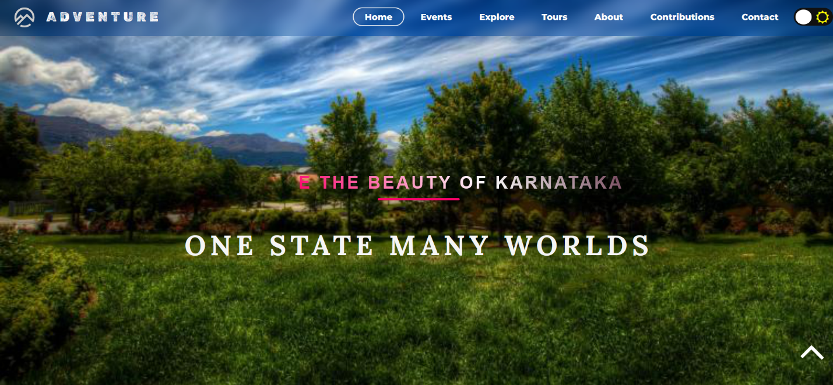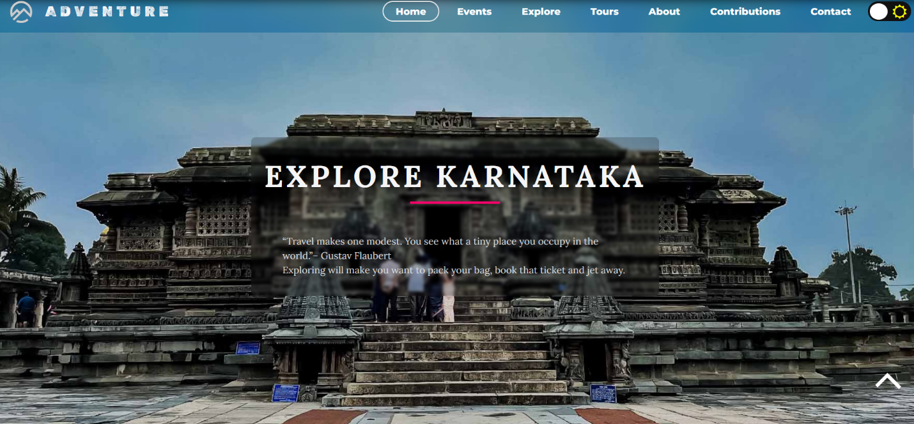

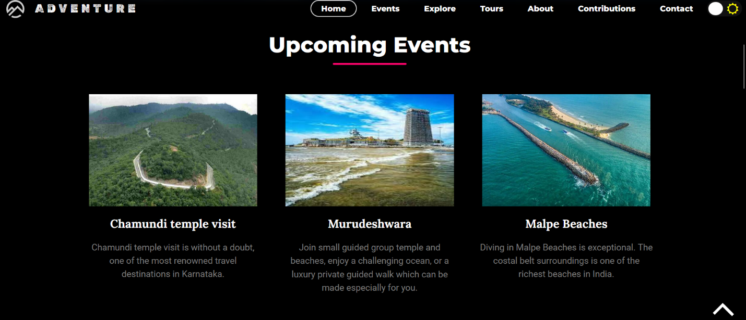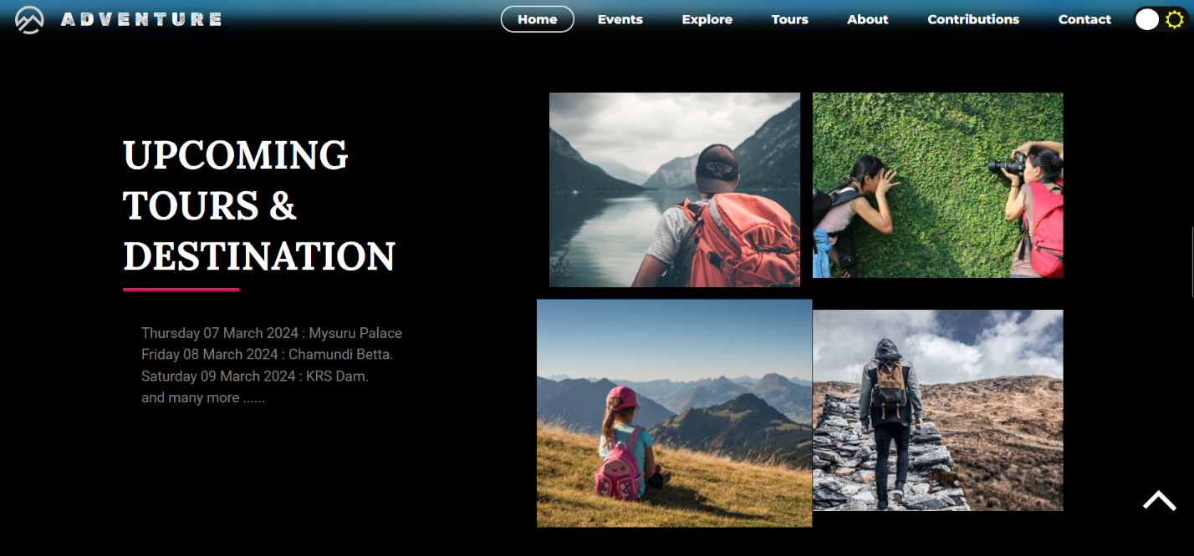

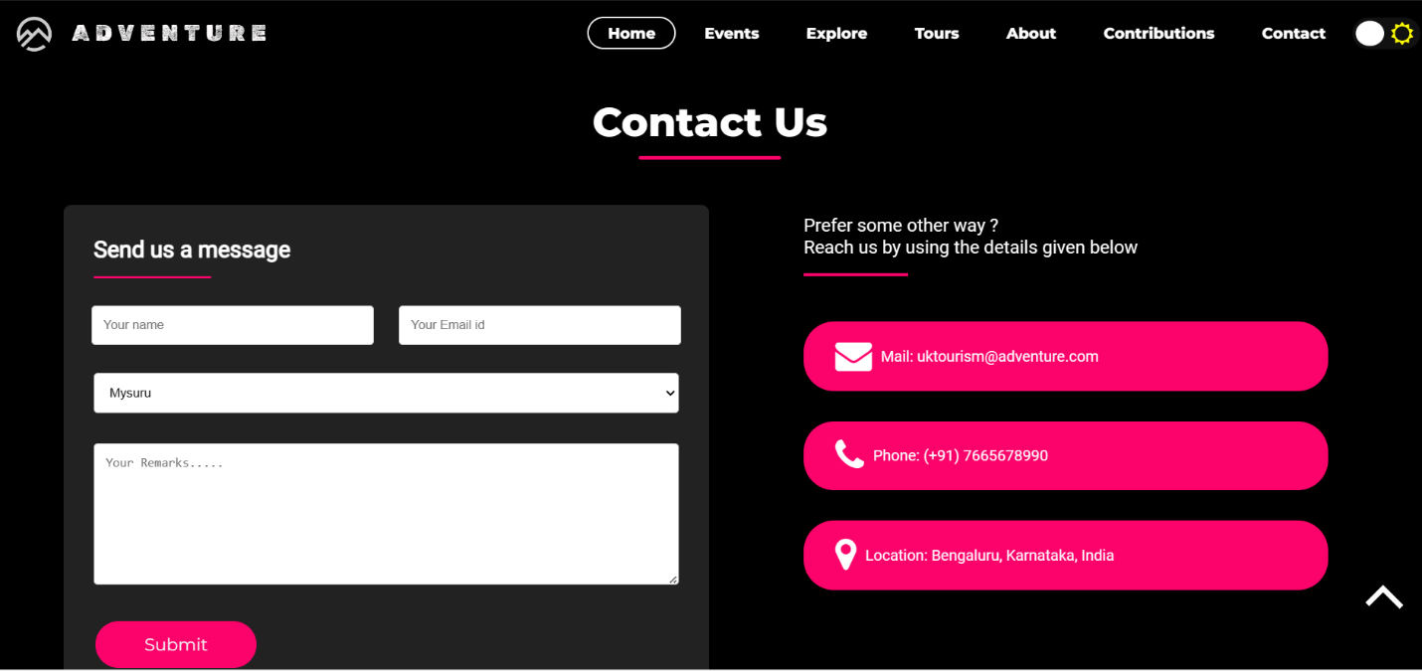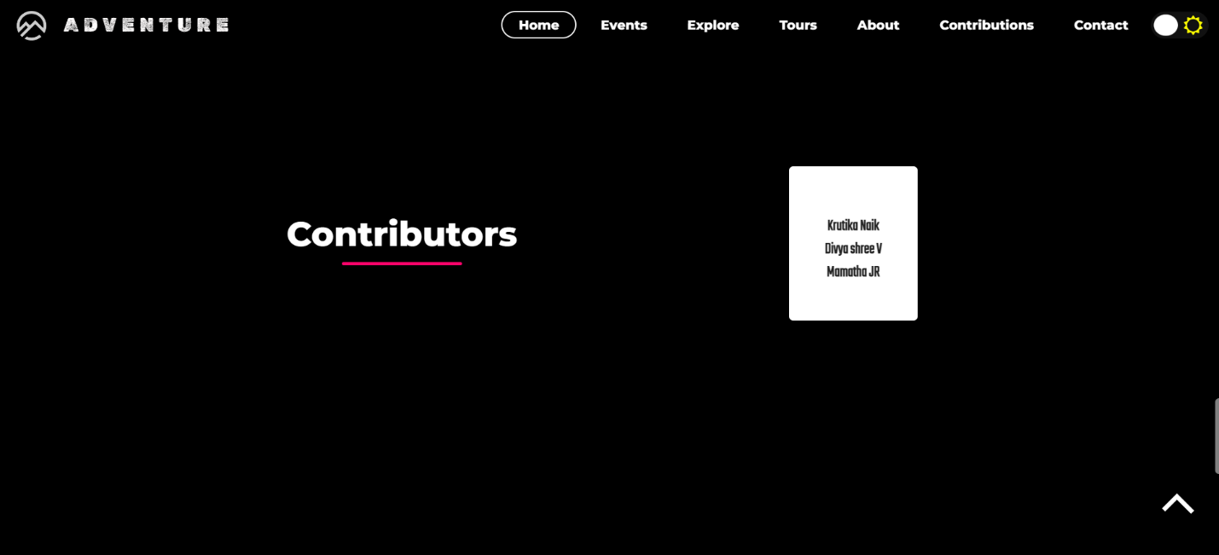

**Feedback:**

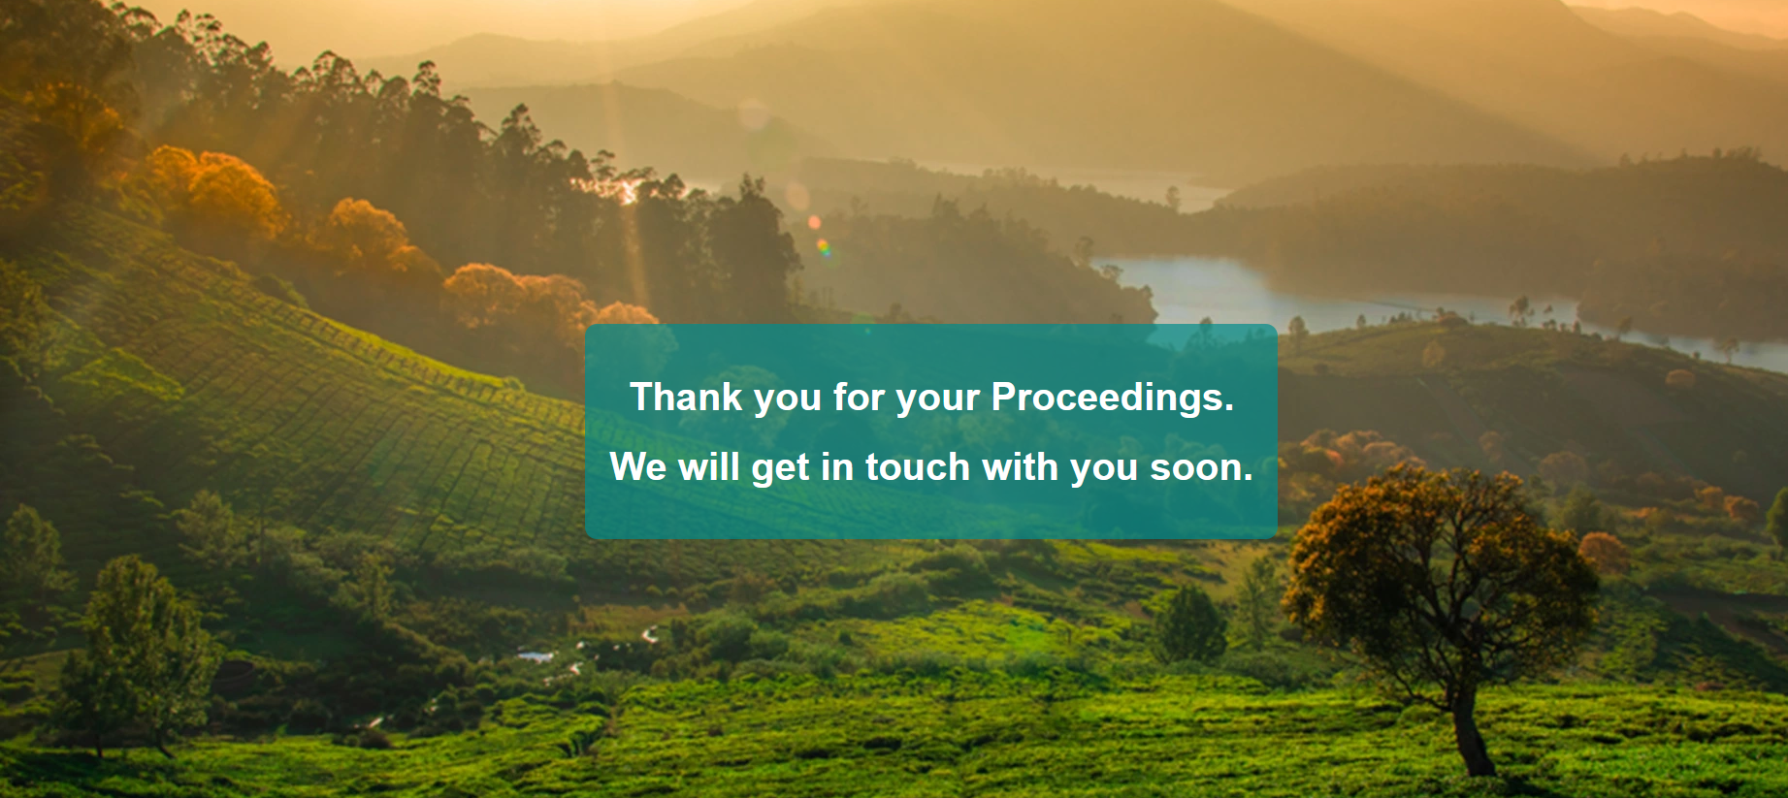

**Conclusion:**

Implemented Angular routing to enable seamless navigation between different sections of the website, enhancing user experience and accessibility. Applied CSS for styling and implemented responsive design techniques to ensure the website looks great and functions well across various devices and screen sizes.

In conclusion, the tourism website mini-project using Angular demonstrates the capabilities of Angular in creating dynamic and responsive experiences, providing users with an enjoyable browsing experience.

**References:**

[1] <http://www.esade.edu/cedit2007/pdfs/papers/pdf18.pdf> v Angella, F., Go, F., (2010), Tale of two cities collaborative tourism marketing

[2] A case study from Nelson/Tasman Region, New Zealand, Asia pacific journal of Tourism research, 10(1): 45-57 v Bornhorst, T., Ritchie, B., &Sheehan. L(2010)

[3] Determinant of tourism success for DMOs & destination: “An empircical examination of stakeholders perspective”, Tourism management 31, 572-589 v Buhalis D. and Deimezi O., 2004

[5] <https://docs.spring.io/spring/docs/current/spring-framework-reference/>

[6] <https://docs.spring.io/spring/docs/current/spring-framework-reference/web.html>

[7] <https://www.w3schools.com/html/>